**Tutorial 10**

**AVL Trees and binary heap**

**Instructions**

1. All tutorial sheets will be posted on the Google Classroom.

2. Students are advised to submit tutorial sheets solutions in classroom.

Q1. Consider the following AVL tree

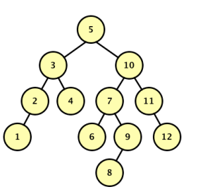

Draw the resulting BST after 5 is removed, but before any rebalancing takes place. Label each node in the resulting tree with its balance factor. Now rebalance the tree that results from (a). Draw a new tree for each rotation that occurs when rebalancing the AVL Tree.

Q2.  Write a program to find the kth smallest element in a given AVL tree.

Q3. Construct a max heap from the given array **Input**: arr[] = {1, 3, 5, 4, 6, 13, 10, 9, 8, 15, 17}

Q4. Implement priority queue using heaps.